**BRP_AniPredictor Guide**

**About**

The folder consists of three main files:

* gui.py
* environment
* md_v5a.0.0.pt

The gui.py file is used to run a Deep Learning Classification model that is trained on classifying the following animal classes:

* Ungulates
* Small Carnivores
* Great Indian Bustard
* Goat/Sheep
* Hare
* Human
* Raptor
* Small Bird
* Wild Pig

Anything that is not classified as something form the above list is moved to the **"Others"** folder.

**Working**

The Deep Learning Classifier works in 4 major steps:

1. First, the images are fed to the Megadetector model which detects any object present in an image. This helps in separating blank images from those with animals/humans.

2. It then crops the images with respect to the bounding box coordinates obtained from the MegaDetector. These cropped images will be used for species level animal classification.

3. The cropped images are then given to the pre-trained classifier trained on a dataset of 50,000 images overall with a per class image strength of more than 5,000 images.

4. The final step includes shifting the original(uncropped) images into respective folders of their classes.

All of this is done just by running a single python script: `gui.py`.

**To successfully run the gui.py script, please go through the prerequisites and procedure for the same.**

**Prerequisites**

* Python ([Download from here](https://www.python.org/downloads/))
* Anaconda ([Download from here](https://www.anaconda.com/download))

**Procedure**

After downloading Python and Anaconda, perform the following steps to successfully run the `gui.py` file in your local machine:

**Step 1:** Open Anaconda prompt

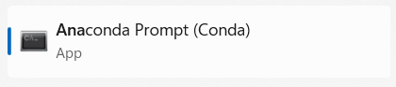

To check if python is installed correctly, write the following command:

 If you get the version displayed on the screen, you are good.

**Step 2:** Copy the path where you have downloaded the **“BRP_Anipredictor”** folder.

**Step 3:** Change the working directory in Anaconda prompt by running the following command



One done; you should see the following format on the screen:

 (Please note that your path may vary)

**Step 4:** Now create the python environment for running the gui.py for running the following command:

(This will take 10-30 mins to run depending on your internet connectivity)

**Step 5:** Now activate the created environment by this command:



Once done the format on screen should change from:

 to 

**Step 6:** Most of the work is done!! Now execute the commands listed below one after the other and you are set to run the gui.py on your PC…

* 
* 
* 
* 
* (This last command might take some time)

**To start the gui.py:**



**The GUI will look something like this:**

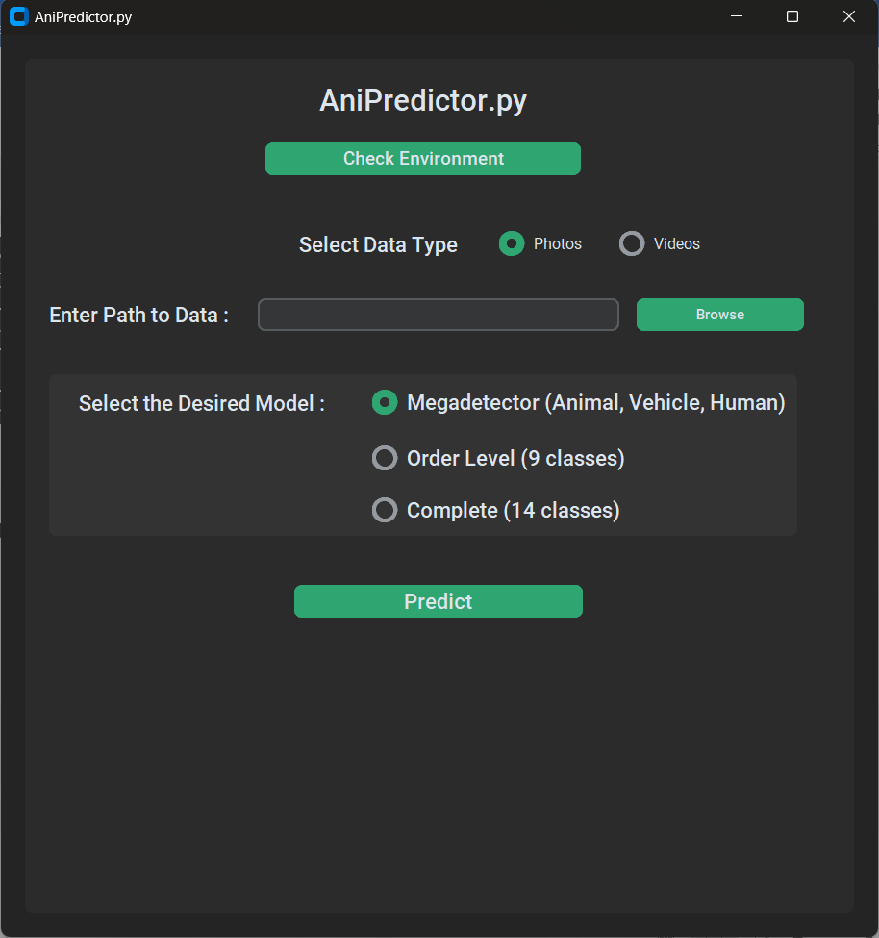

**By following the steps mentioned above, the GUI can be set up successfully in any system. However, activating GPU for faster processing may require some extra efforts for which Varun and I are available :))**